Using DOM on a Table
In this exercise you will experiment with using DOM properties and methods to take user input and dynamically change CSS styles on event triggers. You can find a solution on the course Github repository.

Instructions

- Copy the two exercise files into your working directory: “tableDom.html” and “tabledom.js”. Then, write code in the js file in the function called appendRow() using DOM to append a new row in a different color at the end of the table (see Figure 2). The content of new row is taken from the user. You can use prompt(text, default) function to take the inputs from users.

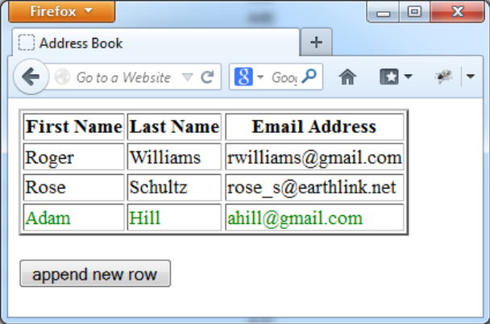
Figure 2 append new row

- Based on 1), add event handler to each row added, that when the user clicks a table cell, it will display the content of that word in bold text. When you click the same cell again, it will be change back to normal text (see Figure 3). https://www.w3schools.com/js/js_htmldom_eventlistener.asp

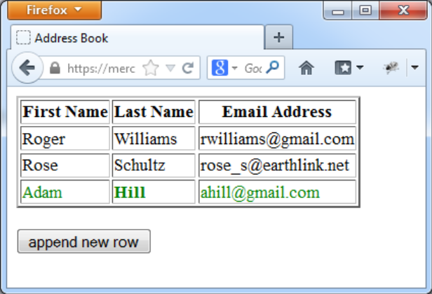
Figure 3 add event listener

- Based on 2), add event handler to handle mouse over event. When the mouse moves over the table, the font size of that field will be increased, and the background color will be changed. When the mouse moves out the content will be changed back to normal size and color(see Figure 4).

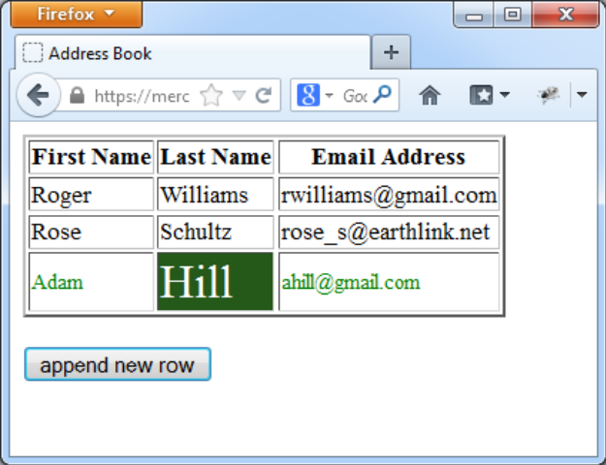
Figure 4 change font size/color when mouse over

